Abstract
Write this last

Introduction
Mesh simplification is an intensively studied field since the 1990s. Over the years, robust CPU based algorithms and in recent years GPU based ones have been freely available. There has been a growing interest in 3d procedural terrain generation in games with titles like No Man’s Sky espeically promising a procedurally generated 3d universe to explore. Optimisation of the meshes that compromise them is challenging as perceived quality has a direct trade off to the number size of the meshes.
The two of the most widely used ways to optimise such terrain meshes;
- A lower resolution mesh can be generated. This is optimal both for generation time and rendering performance but has a major quality impact compared to a high-resolution generation, as a lot of detail can be lost through a low sampling rate. This downside may be algorithm dependent and can even be a good artistic constraint.
- Generate multiple terrains at different resolutions then use a level of detail system, to draw a high-resolution mesh where the player is focused and a low detail one where they aren’t. This is often a workable trade off but has some disadvantages of having to run the terrain generation algorithm multiple times and potentially must be sliced up into tiles or chunks, which can be a limitation with some terrain generation algorithms, like hydraulic erosion.
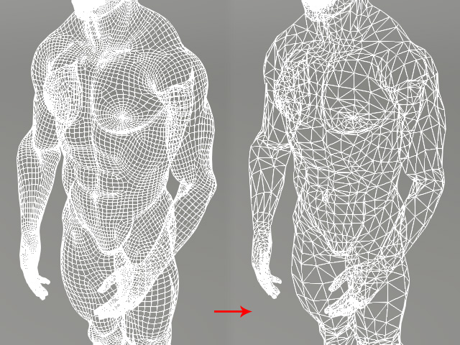
In 3D modelling, mesh simplification (also known as decimation or optimisation) is a tool for reducing the geometry for models such as for characters or items while maintaining a high level of detail.
Applying such an algorithm to a high-resolution generated terrain mesh nets a higher quality result at the same level of geometry compared to running the terrain generation algorithm at a lower input resolution.
Figure 1 https://manual.reallusion.com/Character_Creator_3/ENU/3/Content/Character_Creator_3/3.1/05_Character/Creating_Game_Base_from_Creation_Base.htm https://manual.reallusion.com/Character_Creator_3/ENU/3/Content/Character_Creator_3/Images/Convert_Game_Base_05.jpg
This paper aims to compare two GPU based algorithms to low resolution generation and determine which one is better for runtime convex terrain generation.
- Algorithm A, Embedded Tree Collapse, proposed by Hyunho Lee and Min-Ho Kyung in Parallel mesh simplification using embedded tree collapsing
- Algorithm B, GPU Half Edge, proposed by Mohamed H. Mousa and Mohamed K. Hussein in High-performance simplification of triangular surfaces using a GPU
The contextual analysis will discuss existing literature on mesh simplification algorithms, how they have improved and enhanced by GPU compute over the years and their use in procedural content generation. Following this will be discussion where the top two algorithms will be selected for this comparison.
The scientific questions and hypotheses section will outline the findings of the contextual analysis and present a research question and hypotheses which will determine the experiment design to answer it.

Contextual Analysis

Mesh Simplification
To simplify a mesh is to maintain the shapes and details of the mesh with fewer vertices & triangles.
Two reasons to do this, both revolving around size:
- Atomic size, smaller meshes take up less space on the disk and in the system memory and GPU frame buffer at runtime.
- Rendering performance, the GPU doesn’t need to do as much work to render a smaller meshes, allowing the application to render more meshes, or render more frames in a given unit of time.
The challenge with mesh simplification is, reducing geometry while maintaining a high level of quality, trying to do the same thing with less.
A further challenge comes with doing it in real-time in a game like application. It can take seconds to minutes to simplify a mesh depending on its variables, and while doing so incur a high memory cost.

Literature Review
Since the early 1990s Many CPU based algorithms have been put forward over the years for mesh simplification, with one of the most popular implementations being an algorithm known as QSlim proposed in the 1997. Many algorithms developed since build upon QSlim, but other novel approaches have been proposed since such as Multiple-choice Scheme and other.
To quantitatively measure the quality of an algorithm, the geometric error of the simplified mesh compared to the original mesh is calculated using geometric deviation. Some papers use other methods for measuring quality like Hausdorff distance and/or Root Mean Squared.
As GPUs have gotten faster and more programmable since the late 2000s, GPU implementations of mesh simplification algorithms have been proposed, a paper from AMD in 2007 was the first to take advantage of the high parallelised performance offered by GPUs on large data sets like multimillion polygon meshes and was also the first paper to put forward a real-time implementation of mesh simplification.
Since 2007 many other GPU implementations have been proposed, but not all have compared themselves to each other, from an exhaustive review, most GPU papers build upon the previous paper and compare to that previous implementation.
The current bleeding edge GPU algorithm was proposed by Mousa & Hussein in 2021, they compared only compared their algorithm to QSlim and Multiple-choice scheme. However, they referenced a paper from 2016 by Lee and Kyung which proposed an algorithm using embedded tree collapsing.
Both papers, happened to use a similar, but not identical model for testing, the gargoyle, but did use the same reduction rates. The results appear visually similar, but as Lee and Kyung used MeshLab to measure Hausdorff distance and Root Mean Square to use as their quality metric, it is therefore not comparable to the Mousa & Hussein algorithm.
The execution time for algorithm proposed by Lee and Kyung, are orders of magnitude lower than the Mousa & Hussein algorithm. Lee and Kyung used a more powerful GPU, which may explain this.
Given how much more recent Mousa & Hussein algorithm is, it is expected that it will perform better in execution time and in quality.
This paper proposes to compare these two algorithms.
- Algorithm A, Embedded Tree Collapse, proposed by Hyunho Lee and Min-Ho Kyung Parallel mesh simplification using embedded tree collapsing
- Algorithm B, GPU Half Edge, proposed by Mohamed H. Mousa and Mohamed K. Hussein High-performance simplification of triangular surfaces using a GPU

Both CPU and GPU simplification algorithms are designed to work on arbitrary meshes usually pre-modelled objects from software like Blender, or Maya.
Many have compared to each other, or to the algorithm they are based on/built upon using a small range of different models of various sizes.
There is a lack of research on is generated geometry and terrain geometry in respect to a game’s application.
Why there may be a lack of research could be because to reduce the geometry of a generated mesh is simple if you can control the resolution of the generation, generating a lower resolution mesh. However, higher quality results should be achievable using simplification algorithms.
This paper will compare these two algorithms on simplex-based generated convex terrain geometry and also compare the simplification algorithms to a low-resolution terrain geometry.

Convex Terrain Generation
The type of terrain generation being used to assess the algorithms is similar to heightmap generation but directly displaces vertices in their local up direction around a spherical like body resembling a planet. The resultant mesh is convex.
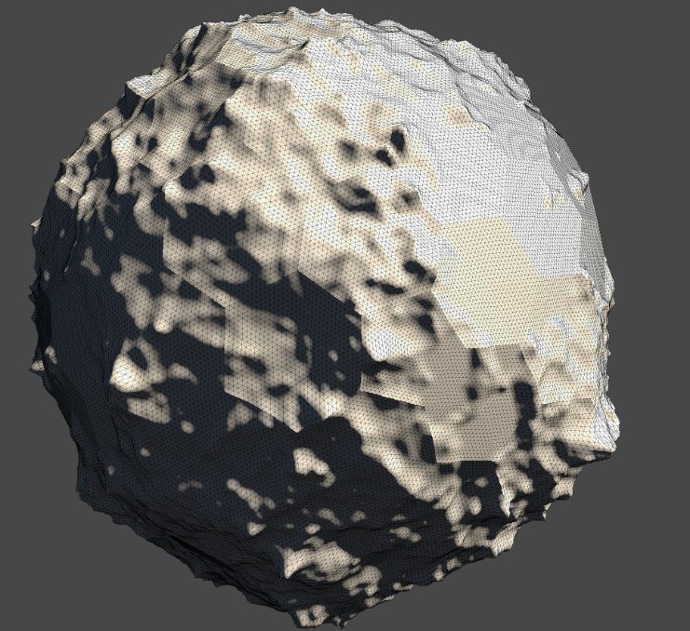
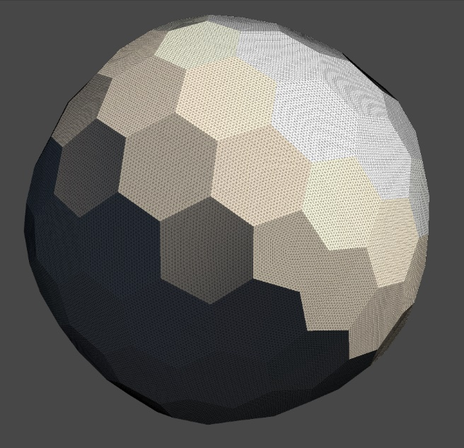
Figure 2 Example base shape
Figure 3 Example Terrain Generation

The terrain generator is something that I have created and am reusing in this paper to use as Blackbox to generate geometry for purposes of testing the algorithms.

Scientific Questions & Hypotheses
On a generated convex terrain mesh, does mesh simplification produce a low geometric error result than a lower resolution generation pass, and which simplification algorithm A or B produces the lowest geometric error for the least compute time.
- Algorithms A and B should have a lower geometric error than a reduced resolution generated mesh
- Algorithm B should run faster than algorithm A
- Algorithm B should have a lower geometric error than algorithm A
- Algorithm B should have a better execution time per geometric error ratio than algorithm A
As the purpose of this paper is to find which of the two algorithms is better, should hypotheses 2-4 be proven false, this information is still useful.

Methodology

Computing Artefact

Requirements and Data Format
To test the hypotheses a computing artefact that implements and can measure the performance of algorithm A and B must be created as well as this it must be able to generate a convex hull terrain mesh and multiple resolutions and with repeatable but randomizable results.
An existing terrain generating artefact will be reused, the data recording and algorithm implementation will be added into framework.
The variables being measured about each algorithm are the execution time of the algorithm and the quality of the result, expressed as geometric error.
As this experiment is to determine which algorithm is better with generated terrain meshes, multiple terrain meshes will be required to verify the null hypotheses is false. The existing frame terrain generator can do this by randomly generating a seed which terrain generation is based off, the seed used to generate the mesh will also need to be recorded.
To simplify the mesh using the algorithms, they need an additional input, how much to simplify the high-resolution mesh by. This is given as a % of the original Triangle count, to maximise the resolution of the test. Each algorithm will be tested using a set of reduction levels.
Reduction Levels
75%
50%
25%
To compare the algorithms to a lower resolution terrain, each terrain will also be generated at a lower resolution with roughly equal to the reduction levels used by the algorithms
A single Data entry element may look like this
Seed | Algorithm | Triangle Count | Reduction Level | Runtime | Geometric Error
1349123 | Algorithm A | 15m | 50% | 3000ms | 50%

A single test set may look like
Seed | Algorithm | Triangle Count | Reduction Level | Runtime | Geometric Error
1349123 | Terrain Gen | 15m | 75% | 300ms | 50%
1349123 | Terrain Gen | 15m | 50% | 30ms | 25%
1349123 | Terrain Gen | 15m | 25% | 3ms | 10%
1349123 | Algorithm A | 15m | 75% | 600ms | 75%
1349123 | Algorithm A | 15m | 50% | 60ms | 50%
1349123 | Algorithm A | 15m | 25% | 6ms | 25%
1349123 | Algorithm B | 15m | 75% | 1000ms | 95%
1349123 | Algorithm B | 15m | 50% | 100ms | 75%
1349123 | Algorithm B | 15m | 25% | 10ms | 50%

Data will be recorded as a csv file.

Detailed Breakdown of Operations
The artefact will test the algorithms through by first generate a high-resolution terrain mesh with N triangles.
The initial resolution will be a broadly configurable variable.
For each algorithm and for each reduction level, the artefact will run the algorithm using the high-resolution mesh as its input to create a simplified mesh, measuring how long it takes the algorithm to create the simplified mesh.
After creating the simplified mesh, the artefact will then compare the simplified result to the high-resolution mesh, by calculating a geometric error score, with 100% meaning identical in shape to the high-resolution mesh.
Finally, the artefact will create a csv entry, recording the terrain generation seed, the starting triangle count, the reduction level, the execution time and the geometric error.

Development Method(s)
Waterfall with meetings every two weeks

Ethical Considerations
The ethical concerns for this project end at the usage of the algorithms being tested within the paper from an IP perspective and the IP of the libraries, frameworks and tools used to carry out the experiment and analysis.
It is acknowledged that this is a computing experiment and so consideration for sustainability (energy usage) has been made, and deemed low as the proposed experiment can be run on a desktop computer, a high-power data centre is not necessary.
The overall ethical risk is low as this project does not involve human participants, or any significant legal issues. This research cannot be weaponised.

Data Management and Analysis Plan

Sampling

Control tests
Each algorithm will be test on a control generated mesh to determine its run-to-run variance in geometric error and execution. If run to run error is high for one or both algorithms, then during the experiment, each step can be repeated and averaged together as many times as needed to be confident in the results.

Experiment Tests
To acquire data to answer each hypothesis, the artefact will start by generating a high-resolution terrain mesh at a specific polygon count (100k triangles). The seed to produce this mesh will be recorded.
Each algorithm will then simplify the high-resolution mesh to a range of steps 75%, 50% and 25% of the original polygon count.
The same will be done by the generation algorithm by making it regenerated the mesh at 75%, 50% and 25% of the original polygon count.
The time milliseconds it takes to simplify from the original to the step will be recorded.
After a simplified mesh has been created, the result will be compared to the original to determine the geometric error % of the simplified relative to the original mesh, using Geometric Deviation.
The geometric error of each algorithm will also be compared to running the generation algorithm at a lower resolution.

Data Analysis
Each hypothesis can be tested using a T test.
library(readr)
dat <- read_csv("H:Stats/tests_data.csv")
view(dat)
summary(dat)
t.test(x~y)
Figure 4 R code example

Summary of Future Work and Pathways to Impact
Maybe do a wider study?

Bibliography
See Zotero for now cos not made any citations.

